BEFORE BEGINNING…
STEP 1: Research and Investigation

WAYS TO INVESTIGATE:

FIRST HAND:  - Interviews  - Site visit  - Personal experience (writing in your own words) | SECOND HAND:  - Videos  - Articles  - Reputable websites  - Blogs  - Podcasts

WAYS TO DOCUMENT:
- Photos
- Videos
- Journaling
- Sketching
- Note taking

FORMULATING QUESTIONS TO HELP DEVELOP IDEAS:
- Reflect on documentation of experiences
- Think about past and current experiences and work, as well as knowledge, skills, intentions
and goals
- Inquiry about materials, processes and ideas
- Open-ended questions that begin with what if, how, why
- Focus on questions that can guide thinking and making
- Envision possibilities for investigation within and beyond the disciplines of art and design
- Organize questions by grouping similar ones together
- Evaluate and rank questions according to their potential for discovery
- Exchange constructive feedback about clarity and the potential for each other’s questions to inspire in-depth investigation over time (HINT: peer critiques)

STEP 2: Practice, Experimentation and Revision
WORKING OUT IDEAS WITHIN YOUR SKETCHBOOK
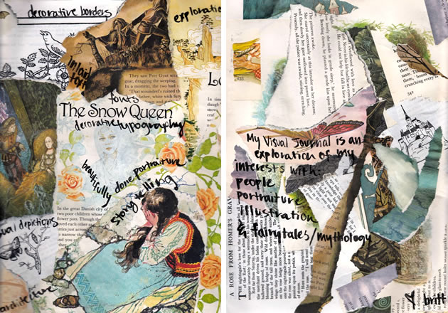

- Each page should be a different idea that goes along with your sustained investigation topic
- Keep adding to it as you think of new ideas over time
- Document everything
- Fill the space with meaningful content
  - Add drawing, writing, notes, collage images, sketch ideas and color
  - This will be the springboard for your art projects

